

NationalTextile University
DepartmentofComputerScience

Subject:
Operating Syatem

Submittedto:
Sir Nasir Mahmood

Submittedby:

Hadi Muhammad

Reg number:

23-NTU-CS-1160

Lab no. :

14th
Docker Home task

Whole project structure:

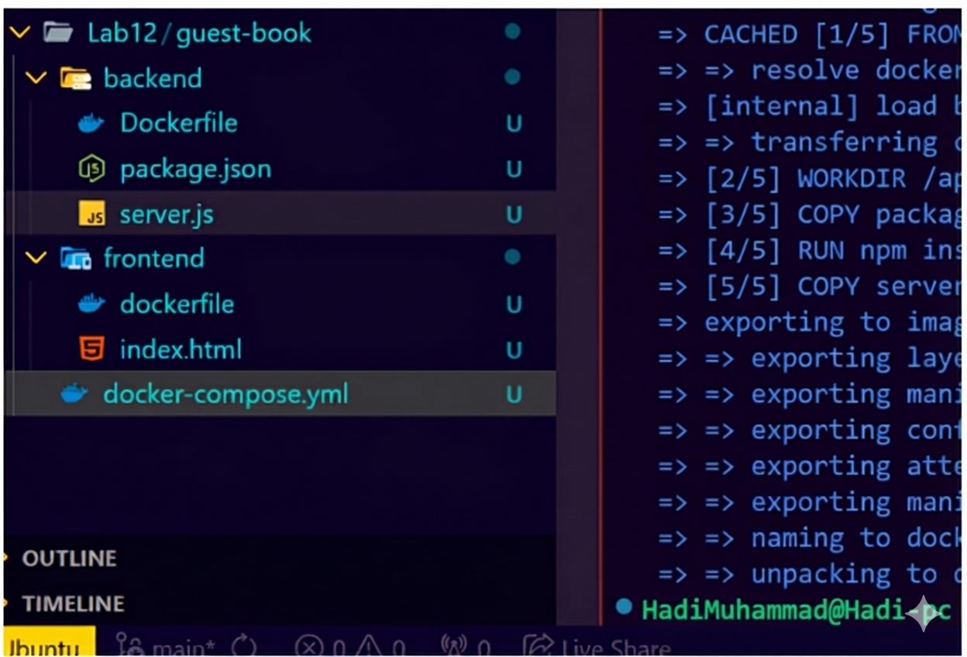

Backend image creation:
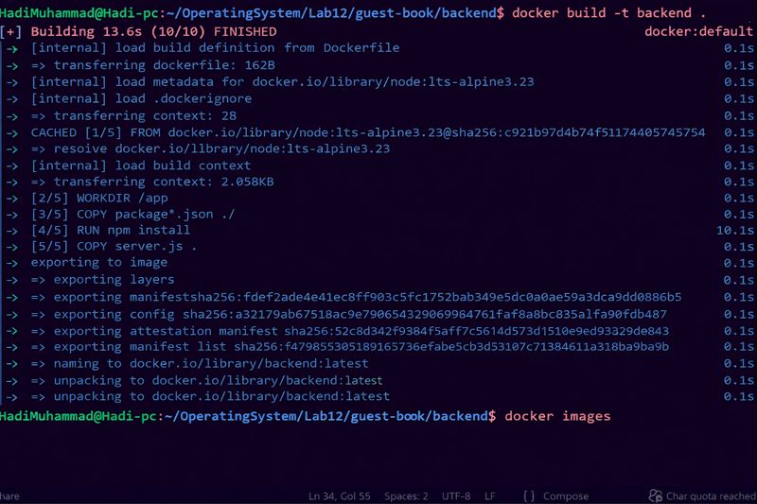

Frontend image creation:
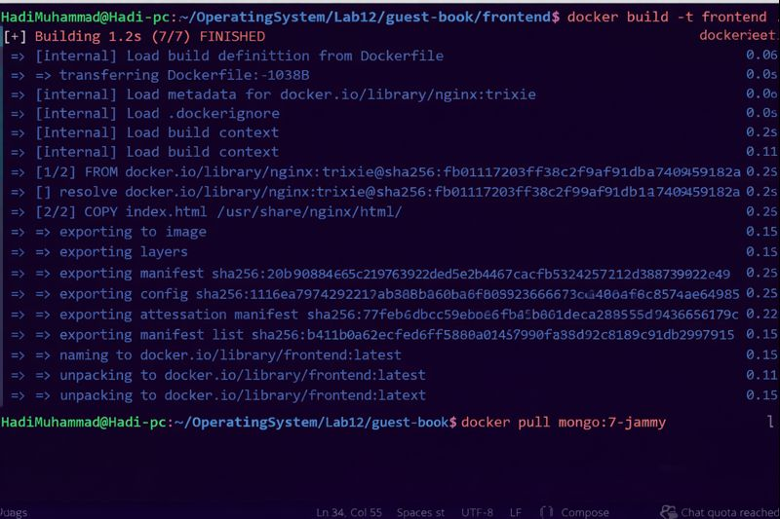

Webpage ScreenShot:

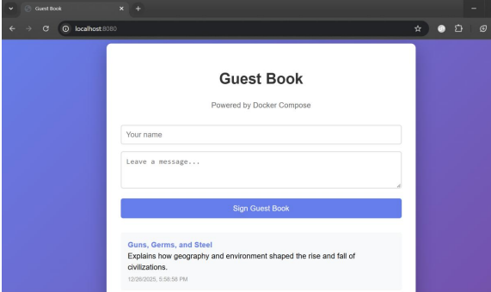

docker-compose.yml File Code:
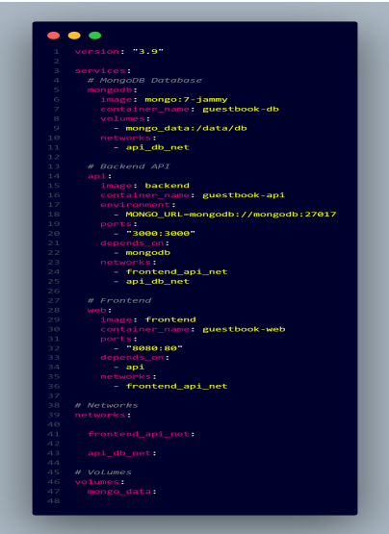
Backend/Dockerfile:
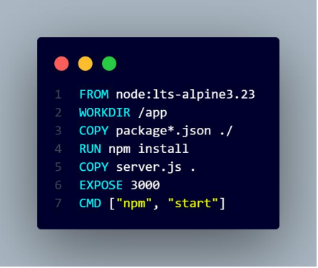
Frontend/Dockerfile:
